How to Create Video Lectures using PowerPoint and YouTube (PowerPoint 2010 - PC)
This handout will guide you through the process on how to create a narrated slide presentation using the voiceover feature in PowerPoint. Once created, you will learn how to convert the PowerPoint file into an mp4 video file, upload it to YouTube and transcribe using tools in YouTube.
Step 1:
Open or create a new PowerPoint
Step 2:
Select the “Slide Show” tab from the Ribbon Menu & then select “Record Slide Show” then select “Start Recording From Beginning.” Record your voice on each slide.
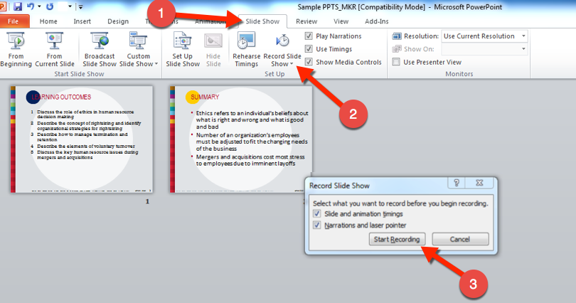
Step 3:
Go to “File”, choose “Save and Send”, and then select “Create a Video.” You can use the default settings or change them (I use Internet and DVD, but leave the Use Recorded Timings and Narration). Lastly, select “Create Video.”
The video file will save as a “Windows Media Video File”.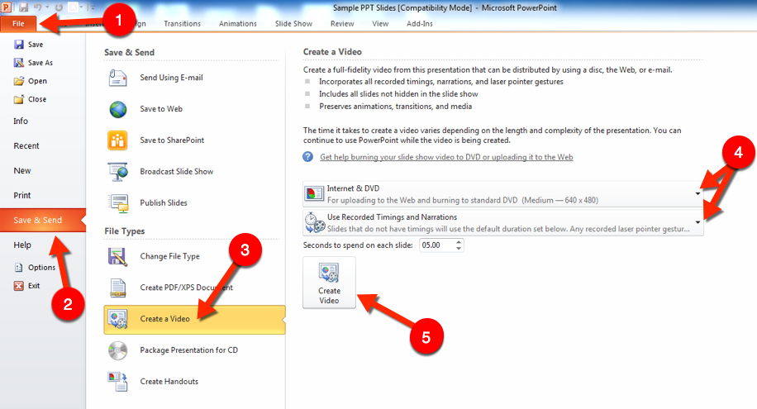
Step 4:
Upload the Windows Media File to your YouTube Account.
Step 5:
Transcribe video by using the automated tool and clean up or type in the words as they are spoken. Then publish the closed captions. You will need to locate the embed code for the video (find the “Share” button under the video preview and copy the code).

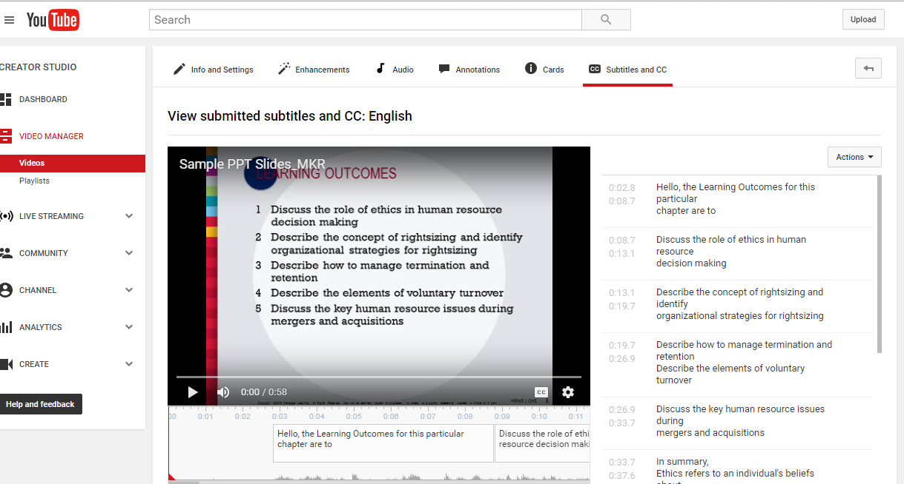
Step 6:
To upload the video into your D2L course content area, click “Create New File” located under the “add” dropdown menu. Next, add a title of the video to the file. Then, click on “Insert Stuff”, located on the HTML Editor toolbar. Click on “Embed Code” and copy the embedded code from YouTube. Select “Insert”. Lastly, publish the HTML page.
Created By: Kathy Rhodes (Ed Tech 2016)

