Create Knowledge Checks
Log into D2L.
Go to course you are creating knowledge check in.
Go to course content area.
Select module where you want to add knowledge check.
Click on the New drop down button and select Create a File.
Type in a name for the knowledge check and click on Select a Document Template Dropdown.
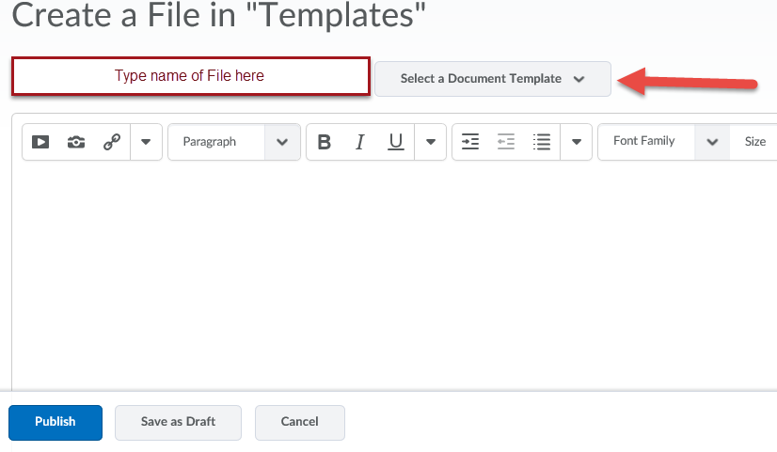
Select the template you want from the drop down list.
Modify the text in the template to correlate to your course.
Next click on the bottom right and go into the HTML coding section.
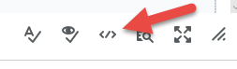
In the code find the line that says:
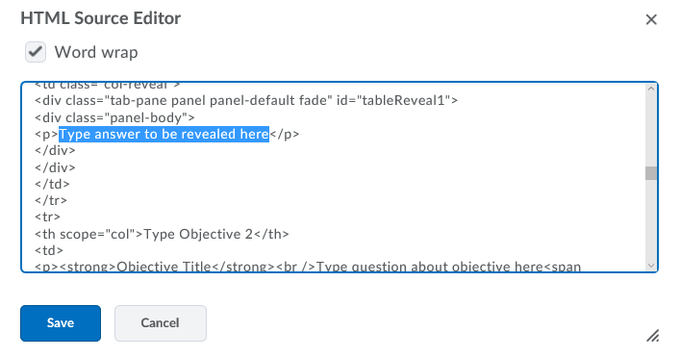
Only modify the part that is highlighted above for each question.
*** Do not delete the <p> before the highlighted text or the </p> after it ***
Once you have modified the text click on Save then Save as Draft.
Go to the item and view it to ensure it works properly and there is not any extra text showing you do not need.

