How to use the Awards Tool

Step 1 – Open a course in D2L and click on “Awards”
Step 2 - Click “Course Awards” to see all awards available in the course. 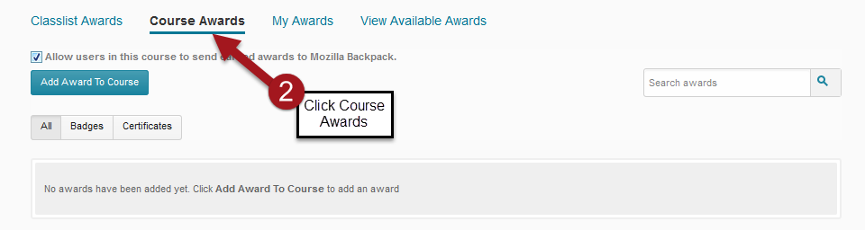
Step 3 - Click “Add Award to Course” 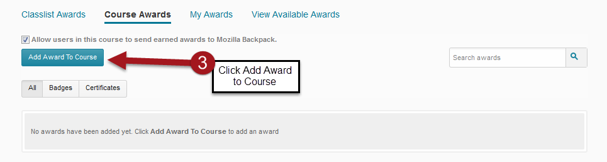
Step 4 - Click “Create Award” 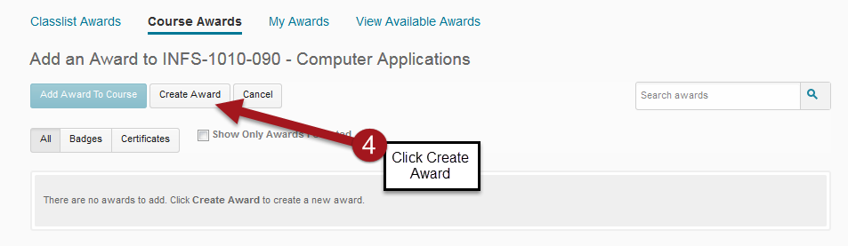

Step 5 - Enter name and short description for award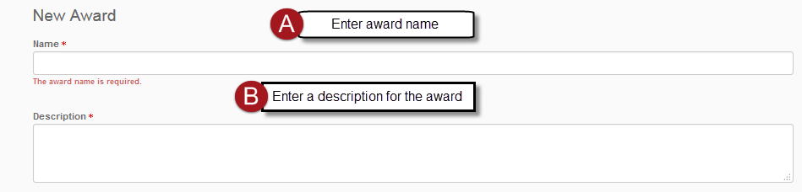
Step 6 – For Award Type select “Badge or Certificate” 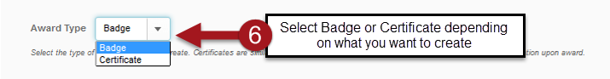

Step 7 – Set up Availability by choosing one or both
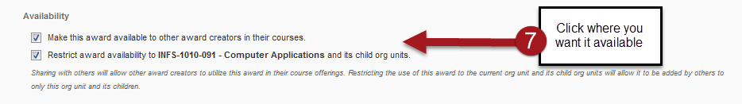

Step 8 - When award will expire
Note: If you want to set an expiration date your options are listed below. By default, the award does not expire
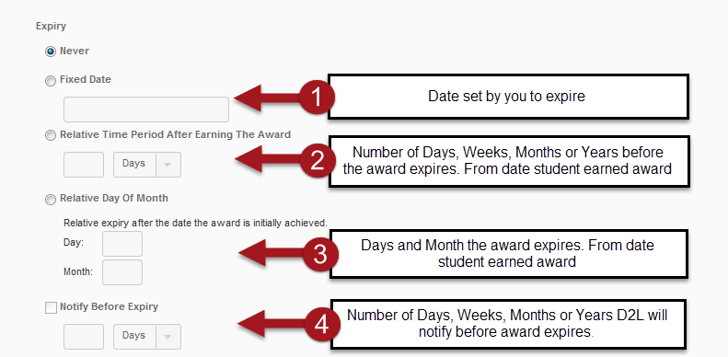

Step 9 – For Badge Select a badge from D2L’s library or use your own. 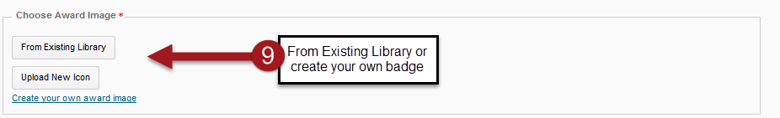

Step 10 - For Certificate select from D2L’s library or use your own
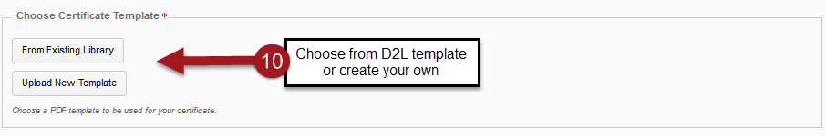

Here is an example of D2L’s certificate
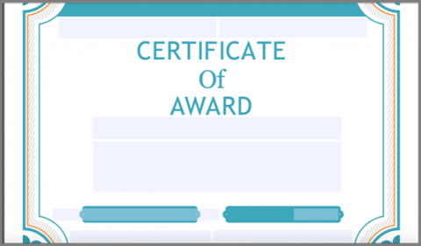
Step 11 – Verify the information below is in the fields
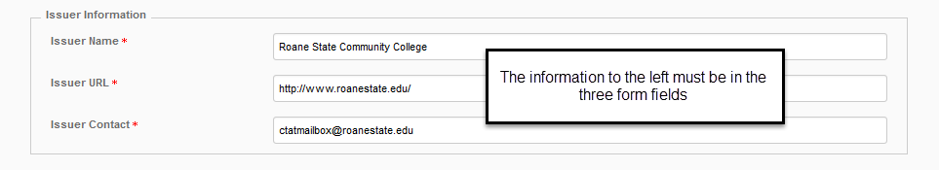

Step 12 – Issue Award
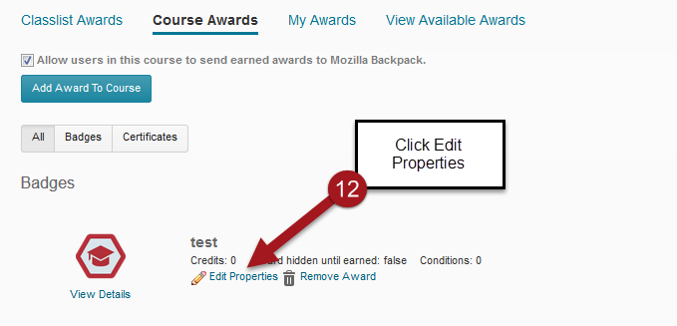

Step 13 – Click Create to set up release conditions
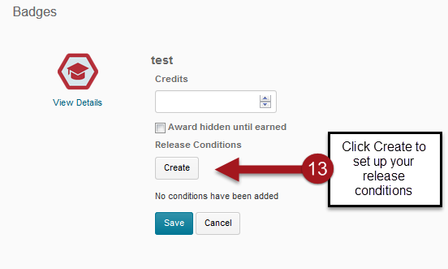

Step 14 – Select the release condition you want
